Soyuz Training — Russia
August 27 - 31, 2007

I left for Moscow on Saturday. Normally, I would have been on the standard government issue Delta flight like I took last time when I flew over in June. However, because it took "them" so long to decide when I needed to start my training in Russia, that by the time they went to make reservations, it was impossible to make decent connections. At first, the reservation was for me to leave Houston on a 6:30 a.m. flight to Atlanta, but leave Atlanta at 3:45 in the afternoon. No thank you. And, come to find out, that Delta's winter schedule is such that one cannot simply do the Moscow to Atlanta flight on the return. They do not fly that route in the winter, evidently. So, one has to fly first from Moscow to New York City (JFK Airport). But, naturally, there is no flight from JFK to Houston, which, by the way, boggles my mind. How can there be no direct fight between the fourth largest city in the country and the largest? They used to fly that route. Silly hub and spoke airline plan. But, I digress. . .

So, leaving JFK the route is first fly to Atlanta and then finally on to Houston. Needless to say, that adds several hours to the trip and makes the total travel time over 24 hours. Plus, you get into Houston at something like 11 p.m., which means you are home after midnight. No thank you to that, as well. So, after a little bit of prodding from me, the travel folks were able to find a travel regulation that said in cases where you would have to leave your house before six in the morning or get home after midnight, you do not have to fly the government required airline between the cities. But, I do still have to fly an American based carrier. So, my trip turned out to be a United fight (code shared with Lufthansa and operated by Lufthansa) to Frankfurt, then Lufthansa to Moscow. On the way back, it is Air France to Paris and then Continental to Houston. Much better routing and much less "time on the road."

The United/Lufthansa flight left later in the day than the Delta flight, though it did leave from Intercontinental rather than Hobby. But, I liked having half a day at home before going. That way I did not have to rush out of the house first thing in the morning. And Andy and I were able to get a run in, which was really nice. As expected, my luggage was overweight. It is not easy packing for three months. Who knows what you may want/need to wear in October. . . But, since this is my initial training trip over, the government was willing to pay for excess baggage. I would say that fifty dollars was money well spent, though I am sure I did not pack enough. By the way, if I had been in first or business class, my luggage would not have been overweight. I guess wealthy people's clothes weigh more.

My thoughts on Lufthansa - seats are just as uncomfortable and cramped and the movies are just as inane, but, you do have to pay for alcohol and the food is marginally better. Plus, after they have served the food, they come around with bottles in hand asking if anyone would like more wine. And, if your glass was full when they came around with the bottles, but empty when they were serving coffee, it is "no problem." Quite civilized, if you ask me.
It was interesting being on this flight because the announcements are made in German first and then English. I found myself trying to remember my German from so many years ago. It was 21 years ago when I studied German in Germany. Yikes! It used to be that when I struggled for a word in Russian, my German would pop in. Now, it is the other way ‘round.

OK, Lufthansa officially beat the pants off of the American carriers. They came around after the tea and coffee service with a Bailey's or cognac service. How many times have you seen that back in coach? The only problem with the flight to Frankfurt was my row partner. I do not know why but at the airport my seat was changed from 30c to 39d. Both were aisle seats (my preference on long flight since I like to get up and walk around). But, the person I was next to in row 39 (actually, a very nice German young man), unfortunately, seemed to subscribe to non-American standards of hygiene. That is something that is hard to ignore.

But, even if my nose was tormented, my ears were happy. One benefit of being a Russia-training crew member is that I am eligible to check out a Bose noise-cancelling headset. That is some amazing technology. It will drown out a crying baby (two rows in front of me), but, it will significantly cut down on general plane and engine noise. They definitely made sleeping a bit more restful.

By and large the flight to Frankfurt was uneventful. I had a few hours to kill in Frankfurt, and then it was on to Moscow and Star City.

Back in the Soviet times, Star City was a closed city where the cosmonauts would live and train. In fact, everyone who worked there lived behind its walls. These days, it is on the map, but it is still semi-closed. You have to have an access card to get in. But, it is still a little city where people live, although you do not have to live here if you work at the training center. It is about an hour from the airport on a good traffic day. Three hours on a bad traffic day. The airport is on the northwest side of Moscow and Star City in on the northeast side. But, when you have twelve million plus people in a city, you are mostly going to have bad traffic days.

On the way out to Star City, we stopped at a grocery store for a supply of food. There are only the food basics (sort of) in Star City. If you want any variety or want what they may not have gotten in that particular day, you have to shop elsewhere. Usually, that meant a trek into Moscow for food. Now there is a large "hypermarket" in a neighboring town (think Walmart), so one does have to go so far to shop for something other than bread and cheese. Food in Russia is not cheap, but at least now there is some variety. It is definitely better than when I lived in Moscow previously and it getting better all the time.
It was probably close to 8:00 p.m. Sunday by the time I finally got to where I was to live. The astronauts who train in Star City live in what we call "The Cottages." (See attached picture - I am in "Cottage 6", last door on right.) These are a set of duplexes that NASA had built. They are not bad. They are basically six three-bedroom houses (in sets of two). The Cottages are about a 10-minute walk from the training facilities, so it is quite convenient in terms of your commute. If you are out here when there are only a few people training, then you may get your own house to live in. If there are a lot of people, then you have to share. This time, I will be sharing a house with one other person for a week, and then I will have the place to myself. It is a basic house Ð kitchen, dining room, small study and living room downstairs and three bedrooms and two bathrooms upstairs. And, since NASA provided them, they have them wired. So we have NASA computer connections and a NASA provided phone (which pretends it is in Huntsville Alabama - I am not sure how that works - some sort of technological magic). The phone is nice, because if people from the U.S. want to call, then it is only as if they are calling Alabama. I got lucky this time and have the master bedroom, which means I have my own bathroom. Bonus. |  | 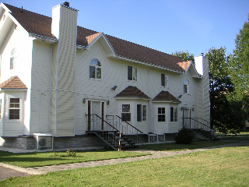

Once I arrived, I did a little unpacking, picked up some of my training materials, had dinner and then pretty much crashed.

Bright and early-ish (9:30) Monday I started into my training week. The first thing I had was a training pre-brief. It was not at all what I expected. I expected a small group of the Russian trainers explaining what I would be doing here. It, in fact, was all the training heads (I think) and who knows else in a large auditorium type room. I had to sit up front with the leader of this affair. I have no idea who he was; he did not introduce himself to me. He gave an introduction and then turned it over to me for me to talk about myself (yes, there was an interpreter there). Then the lead training scheduler did a short presentation to the group on my plan of attack. What I got out of it is that I have a compressed schedule because the time is short and they have cut back on language training to fit everything in. What made this the most bizarre was that the cosmonaut training facility is currently run by the military (that is who has always done it historically Ð next year it is being changed over to being run by civilians). So, everyone in the "audience" was in a military uniform. It was strange and I felt out of place. I wish I had known I needed to make a speech. . .

Afterwards, I had a short tour of the training facilities. These are behind another layer of security. I am not sure why, but you do have to pass through a security check point to get to the "training territory." As best I can tell, I will have all my classes or simulations in 3 or 4 different buildings. Then it was on to my first class. I was supposed to have a familiarization session in a Soyuz simulator. But the simulator was occupied, so we went straight to a lecture. The lecture was basically the start of a structures and mechanisms overview of the Soyuz. The Soyuz is made up of three compartments, they are made out of aluminum, the walls are very thin, yada, yada, yada. After a break for lunch back at the cottage, it back for more of the same subject.

Lastly, I had a class on "panels." This class was on the interfaces the crew has to input commands to the Soyuz. It was REALLY hard to stay awake by the end of the training day. After dinner I tried to do some studying in the evening. It was also hard to stay awake then. But, of course, when I needed to go to bed, I got a second wind and then it was hard to sleep. Ah, the joys of jet lag.

My training days here are broken into four, two-hour blocks. The day starts at 9:00, the second period is at 11:00; lunch from 1:00 - 2:00, then back to class at 2:00 and the last period starts at 4:00. I will mostly be having lectures at first covering the theoretical side of the Soyuz spacecraft. Later, I will be doing hand-on classes and finally simulations.

Tuesday the alarm on my phone alarm went off at 6:00 a.m. Urgh, I was in a good sleep at that time. It took me awhile to figure out how to make it stop and how to ensure it was not going to ever do that again. By then, I was far to awake to go back to sleep, so, I went to the gym and spent some time on a treadmill. One of the advantages of The Cottages is that in the basement of one of them, NASA has made a little gym. It has weights and various cardio machines. Those in training here use it regularly and those back from space use it for rehab.

My first class of the day was another lecture on the Soyuz panels. It was more detail on what we covered yesterday. Then, I had a lecture on what is called the onboard complex control system. This class is on the guts behind the panels. How the system process commands to fire thrusters, control your atmosphere, etc. It is kind of like the central computer system of the Soyuz. After my lunch break I had an introductory lecture on the life support systems. The instructor talked about the basics of the atmosphere - how much oxygen a person needs, how much carbon a person creates, how much humidity is present, etc.

My last period of the afternoon was scheduled physical training. It appears that I am going to be scheduled for gym time twice as week. Instead of going to the gym I took a nice, long nap. And then I went to the gym and lifted weights. My housemate made dinner for the folks here so I did not have to cook anything. Right now there are about eight people at the moment between the astronauts, the flight doctor who support us here, and some of the training folks from Houston who also support our training here. It seems to be the standard that a couple times a week, someone will cook for the in-town gang.
Wednesday was a very long day. I definitely did not have enough sleep the night before. I only managed about six and a half hours. That is not enough for me. My first lecture of the day was another lecture on the onboard complex control system. We just kept going through the details of the system and going over the schematics of how the system is put together.

I guess I should mention how the classes are structured. I am the only person going through this theoretical training right now, so I am the only student in my classes. I have an interpreter in every class who will interpret as much or as little as I want/need. Right now, I am pretty much having most everything interpreted. I am following a great deal of the Russian (more than I expected), but just starting off I want to make sure that I am really understanding what they are saying. I will end up having tests on every subject. From what I understand, the tests are all oral and the hardware and software designers come in to administer the tests. Sounds like funÉ Most of the time, there is one other person in class with me. This is one of our Russian Training Integrators - folks from the training department in Houston who are experts on the Russian systems. They do a lot of things in Russia to ensure that the U.S. and Russian training is integrated properly. But, they are also here to make sure we get what we need out of the classes we are taking. If the interpretation is not quite right, they will step in; if the instructor does not go into the right level of detail, they will cover it. They make sure I have all the training materials in both Russian and English. And, because they are experts on the systems, they will help me make sure I am ready for the exams, if I feel like I need help. They are definitely a big help - someone "on your side" looking out for you.

So, after my onboard complex control system class, I had a Russian lesson. Then lunch, then another Russian lesson (4 hours total). The teacher turned out to be one of the ladies from my immersion training. She wore me out. By the end, I could not even sort through the most basic question from her. My day wrapped up with another lecture on the same subject from the morning - more going through the details.

Another person here made dinner for the gang, so I once again did not have to worry about cooking. Then I tried to study and fell asleep pretty early.

Thursday turned out to be a reasonably light day. My first class was another lecture on the onboard complex control system. I think we have covered just about everything in this system. At least, I think we have covered all the basics. Looking at my "look ahead schedule" for the time I am here, it looks like today's class was the last one in this subject for a while. In about two months, I'll have some more classes on it, and then the exam. I am not quite sure why it is scheduled this way, but that is the way it appears to be.

Afterwards, I had a physical training session scheduled. I was pretty tired today still, so I went back to my cottage and took a nap. Afterwards, I felt much better. In the afternoon I only had one class. This one was on the life support systems. This system is one of the bigger one in that there is a lot of different hardware. Not only there is the hardware to maintain the atmosphere, but there is all the equipment that is associated with the space suits that keep you alive should there be a problem and the capsule depressurizes. I will be taking lessons on this subject for many weeks.

For my last period I was scheduled for "admin time." I used this time to go to the gym since I slept during my gym time earlier in the day.

In the evening, I studied, of course. Friday, I start a new subject, the docking system, so I read ahead on some of the materials. It makes the lectures easier if I have some idea what they are talking about. Plus, it helps me follow the Russian. Even though I have the training materials in both English and Russian, I pretty much only read the English versions for now. But all the equipment names and acronyms are still given in Russian in the English texts, so, I am learning the Russian terminology.

Friday was as long as Thursday was short. I had four lectures. Two on the life support systems and two on the docking system. In the life support systems classes we covered the oxygen delivery system (tanks, valves, automatic operations vs manual operations) in one of them and the Soyuz toilet in the other. All I can say about the toilet is that that it is not pretty and it was not designed for women, but it is functional. Since it takes two days to get to the Station after a Soyuz launch, there is no getting around using it. And, I suspect that the toilet on the Station, being in the Russian segment and being Russian built, is similar (though, I don't know for sure).

In the evening there was another group dinner. I can definitely get used to someone else cookin’. . . Afterwards a couple of us relaxed and watched a movie.

On Saturday there was a grocery store run. As mentioned above, going to a decent grocery store is more of an event rather than something you do on a whim. So, a handful of us arranged for one of the NASA drivers to take us to the "Walmart. " The total trip time between travel there and back and shopping - 2 hours. But, now I have another week's worth of food. After that, I spent my day procrastinating, napping, and doing a little bit of studying.

Sunday was also a nap and study day. And that was my first training week.

By the way, for those who are curious about the weather, I think it is safe to say that summer is over here. Most of this week the temperature was in the 60's during the day. Just imagine - sweater weather in August. . . It was also kind of cloudy and occasionally rainy, too. The weekend was a bit colder (though, good napping weather), but I think it is supposed to be back up to the mid-sixties next week. I hope.

© Shannon Walker 2009

Soyuz Training — Russia
September 3 - 7, 2007

I had a pretty good day on Monday. Even though I am still far too acquainted with 3:00 a.m., I had a decent night's sleep. I am finally getting close to the Moscow time zone. My first class of the day was what is termed a "practice session" in the Soyuz simulator. This means some hands-on time in a simulator. This simulator session was on the life support systems. We went through and operated all the hardware that we had talked about in class - turned on and off the air systems, the water system, the toilet and even worked through some depressurization scenarios. It was fun to be actually pushing some buttons and turning valves to make things happen.

But, then the fun ended and I had another two-hour lecture - more details on how and when some of the valves in said life support system operate.

After lunch it was an afternoon of the docking system. It was long, but at least the instructor is entertaining. It could definitely have been a lot worse. Although, during the last period of the day we did not take a break. So that was two straight hours of going through schematics on how the automatic portion of a docking works. Urgh! I think I may have only one more true lecture on this subject and then the rest of the classes are either a practice session in the simulator or preparation sessions for my exam on Friday. This system makes a whole lot of sense to me, but I saw a list of potential exam questions today. Wow! It is a lot of stuff. Most of the questions seem to be very general in nature - along the lines of describe all the parts, tell how everything works, name every command along with its feedback to the crew. And, then tell the same kinds of things if something does not go right. So, of course, I spent my evening studying.

Tuesday was a hard day - not because the classes were particularly hard, but because I had yet another difficult-to-sleep night. I got on a roll studying Monday night and by the time I quit, it was probably about 12:30 a.m. But, by then, my brain was swimming with all the things I am trying to learn and I could not shut it off. I tossed and turned far too long before going to sleep. So, I felt sluggish in my classes. I had a life support class first and the instructor started off by asking me questions about what we had covered yesterday and I could not dredge up the information. That was not fun. Usually I can call on something I know from my past experience to at least get going in the right direction.

Afterwards it was two lectures on the docking system. Well, one lecture and one "study session." But, it was really two lectures. Because my schedule is compressed, we do not have as many lectures to go through what we are expected to go through as one normally does. As such, we had not quite gone over all the material that we needed to go through by the time my study sessions were scheduled. The expectation in the study sessions is that you will have studied a lot already and will use the time to ask questions of the instructor to clarify your knowledge. I had studied a lot and I did have questions, but it was clear to me that I still have a long way to go. Good thing I had Russian homework and life support stuff I need to learn Tuesday night as well. My last period of the day was scheduled gym time. It felt good to get some exercise before hitting the books.
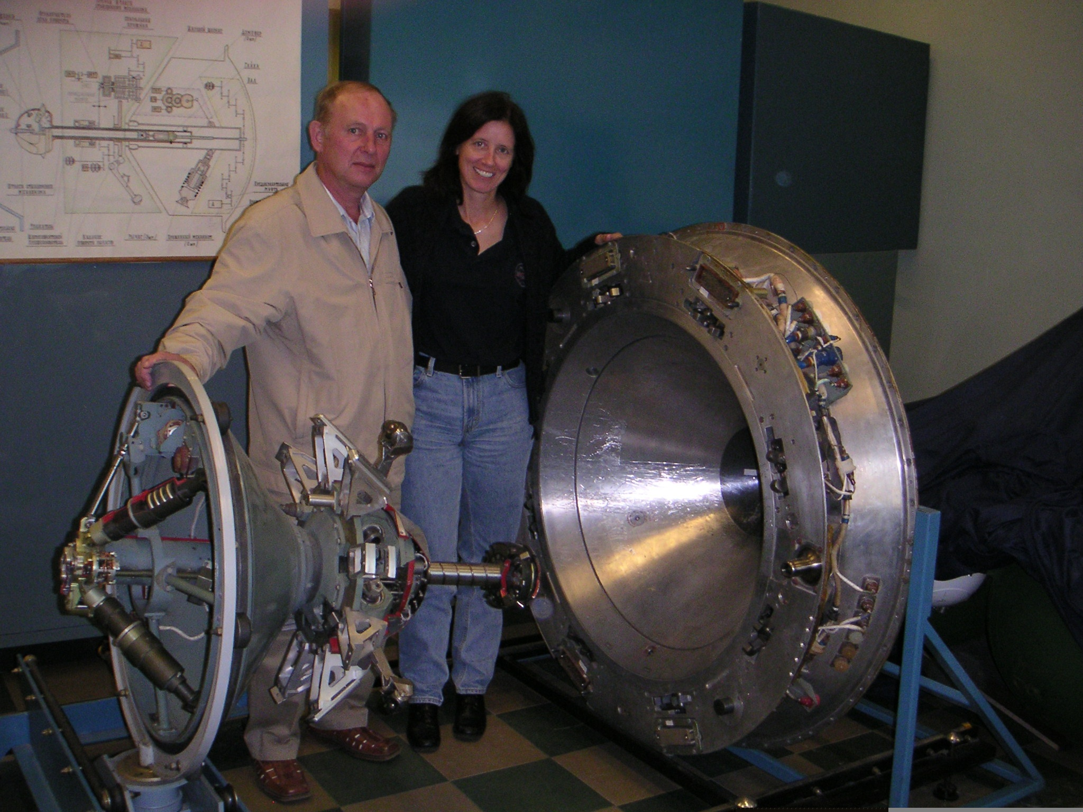
1. Pavlov, Shannon and Docking System

My first period Wednesday morning was interesting. It was another preparation session for my exam on Friday. Most of the class involved the instructor asking me question as if we were doing an exam. For just about every one, I could come up with something close to the answer, but for every one, he would say to me, "Shannon, you are right, but here is the pretty way to say it." And, then he would tell me his phraseology. It was interesting because in some ways you are expected to know every minute detail, but in other ways, they just want a very high-level answer to the question. This was a very instructive session not on technical matters (though, there was some of that), but on how the Russians give tests and how they expect answers.

Following my prep class, I had a Russian lesson. It is interesting; the instructors really seem to be concerned about me overdoing things. They are always talking about taking care of my health - making sure I rest during our breaks, make sure I get up and walk around, telling me not to study too much at night, etc. It is a very Russian approach to life. After my first Russian class, my instructor and I were heading in the same direction for lunch - me to my cottage and she to a cafeteria somewhere. I was going to wait for one of the other Russian teachers since I knew that they would be eating together, but my teacher suddenly pushed me (gently) and said that I should go ahead. She said that we had been talking a lot and I needed to take a break and think in English. Of course, this is coming from the woman that never takes a break in class. "Are you tired?" "A little." "OK, so letÕs move on to some grammar drills. . . " You just have to laugh.

After lunch it was another two hours of Russian and then I had a practice session in the Soyuz simulator on the docking system. We first looked at some of the hardware and then we ran a few scenarios - automatic docking, manual undocking, and the like. The entire time the instructor would have me execute a command and then ask me a whole bunch of questions along the lines of why we get this indication or why do we not get that indication. Hard, but also another good opportunity to get everything fixed in my brain.

Naturally my evening was spent with my training manuals. And, it was a very long evening. Though, I did take a break and go to the gym for a while. I think all the docking system subtleties are finally coming together for me so that I may actually remember them.

Thursday, I discovered that maybe I had a bit more studying to do for my exam. We had another question and answer session and there were plenty of times that my answers either were not pretty enough or just not to my instructor's liking. Oh well.

My two other classes for the day were on the life support system, but this time I had a different instructor. Today we talked about the launch and entry suit that we wear that protects us in case of a sudden depressurization of the spacecraft - four hours of going over all its parts and pieces and how all the valves and associated equipment worked. It was a fun class because he had all the hardware there so when we were talking about how all the air would flow through the suit to keep you cool we could actually look at the lines on a real suit. I also got to practice the proper way to close the helmet and attach the gloves to ensure that you have good seals. It is always good when you get to work with the actual hardware. And, the neat thing was that I probably understood at least 80% of the class in Russian. It was a pretty straightforward topic, but it was nice that I was able to follow it. I still cannot cough up a simple sentence to say quickly enough for my liking because I still do not seem to think on my feet fast enough. But, I know that will come in time.

My last period of the day was gym time. I, however, did not go to the gym. I was pretty tired, so I figured the best use of my time was a short nap to recharge my batteries before I hit the books on the docking system for the last time before my test. So, that is exactly what I did. After my nap, I made myself dinner and reviewed the docking system one last time.

Friday morning brought my long-awaited test. I think it went very well. The test was given in the same room as I had been taking the classes so I could point to and or touch the hardware as needed. There was a lady there from the company who builds the hardware (presumably she is considered the hardware designer now, although, the original designer probably retired years ago - at any rate, she is the "owner"). And, there was some guy in a military uniform. To be honest, I do not know his role/place in things. But, he got to ask questions as well. For the test, I sat in the seat where my instructor normally sat, the examiners (those two plus my instructor) sat across from me (a desk/table between us). The interpreter sat to my left. One of our Russian training integrators sat in the back of the room. She was there to write down the questions, so that we have a continuing history of the types of questions that are asked.

For the next 40 minutes or so, they asked questions and I answered them. I only got slightly confused one time when I could not remember how a command to fire the back away jets upon a missed docking is issued. But, my instructor asked a clarifying question and I quickly got back on track. When they had run out of questions, the test was over. One of the examiners said that I had done well. They liked the fact that my answers were short and to the point and that did not leave them any room to ask more questions (i.e., I did not dig myself a hole). I guess my answers were "pretty." So, it seems I did learn at least one lesson from my prep sessions - the point of the test is not to wow them with all the minutiae that you know, but to hit the high points. Basically give simple rote answers when being asked, say, what is the function of X. . . X does the following three things. . . No need to go into that the box has these inputs or those output or works only every other Thursday. If they want to know that level of detail, they will ask. By and large, I was not asked too much detail and the detail I was asked was simple.

At one point, I could tell that the interpreter helped me out a little bit. To answer one question, I needed to go through a procedure and explain all the ins and outs of what it does. I got to a point where a bunch of indication lights come on. I listed all of them but one because I was going to add some detail about the last light since it was of a slightly different nature than the other lights. However, when the interpreter interpreted my statements, he added in that last light for me. He probably just figured I forgot to mention it. So, since he mentioned it, I did not say anything else about the light and the examiners seemed to accept the answer as it was interpreted. Works for me.

I don't know what score they gave me. Russian tests are normally graded on a 1 - 5 scale with 5 being the best/equivalent of an A. But, I do not know if I was graded in this manner or just on a pass/fail basis. There was some paperwork signed by the examiners at the end, so I am sure there was some sort of score recorded.

After a break of about an hour (during which I went back to my cottage and read some of the material for my next class), I had a class on the survival kit that is in the Soyuz should you have to do an emergency landing and/or you do not land at the expected landing location for some reason. It contains the standard stuff that seems to be in all survival kits - water, food, signal flares, radio, etc. They also have some pretty warm clothes to put on should you come down in a cold, snowy area. And, there are some waterproof clothes should you come down in the water. The only new and interesting item in this survival kit is that they actually have a gun. It is a specially made gun specifically for this survival kit. It has three barrels - one will fire signal cartridges, one will fire shotgun cartridges, and the third will fire rifle bullets. And, it folds up for storage - pretty nifty. Why a gun, you ask? Well, the signal cartridge part is obvious. The shotgun and rifle are for hunting food and protecting yourself against predators. Apparently in the early days of the Soyuz program, there was one landing that was pretty far from the regular landing site (not sure why). The crew landed far in the north and it took until the next day before the rescue team could get there. The crew ended up spending the night in a tree trapped by wolves. So, a gun was added to the survival kit.

I only had one more class for the day and it was a dandy one. I had interpreted my schedule incorrectly. I thought I was going to have another class on the launch and entry suit. I did. . . but I ended up in one. As I was walking back to the training territory after lunch, I met up with the flight doctor that is here. There is always a doctor here to not only take care of any health needs, but to be on hand when the American crewmembers do things such as spacewalk training or getting into a pressure chamber or something that might be dangerous (just like we have doctors on hand for similar training in the U.S.). At any rate, when I saw her, I asked where she was headed and she replied that I was her afternoon. Huh? Turns out that my class was a practical class on getting into the space suit as well as a practical class on suit operations - doing a leak check of the suit, seeing how it operates in the case of a depressurization and things like that. Doing a simulated depressurization means that the suit pressurizes and holds an environment for you, which can be hard on the ears due to the changing pressures. So, the doctor was there to make sure I did not have any problems. I did not. I, in fact, had a lot of fun. It was just pretty darn nifty - in the morning I am having an exam and, in the afternoon, I am in a pressurized space suit. You cannot ask for a better way to end the week. My last period was admin time. So, I went to the gym, having missed it the day before. Then the current gang in town got together for dinner. Afterwards, we relaxed in "Shep's Bar." Shep's Bar is also in one of the basements of one of the cottages. It is right next to the gym. It the result of a lot of hard work from the first American on the International Space Station, Bill Shepherd. He spent many years over in Russia training and he decided that the folks over here needed a place to congregate socially. So, he built the bar. Over the years, donations from the astronauts and other visitors over here have paid for a lot of the "toys" that we now have here - a ping pong table, a pool table, a nice TV and stereo system where we can watch movies. It is really nice to have a place like this because there is nothing else to do in Star City. And, folks do need a place to relax.

On the weekend, we arranged for vans to take us into Moscow so we can eat out at a restaurant and go grocery shopping. It was the first trip to Russia of one for the folks here, so we took one of the vans and went by Red Square and did a little sightseeing. You just cannot come to Russia and not see Red Square. We made it back to Star City in the middle of the afternoon (the traffic was horrible and it probably took us at least an hour and a half to get back). And then it was nap time for me. In the evening we had another group dinner and then watched a movie.

Sunday was a nap and study day.

Weather report: for most of the week, the weather was actually quite nice. It was probably in the upper sixties in the middle of the day and was quite sunny. But, that was probably the last of it. Friday night it got quite a bit colder. Saturday was in the upper fifties and Sunday was in the lower fifties and raining - definitely a study and nap kind of day.

© Shannon Walker 2009

Soyuz Training — Russia
September 10 - 14, 2007

I had a full day of classes on Monday. I started off with a class on the parts and pieces of the system that is used to monitor and equalize the pressures between the hatches before you open them. After a docking, you first check to make sure that everything is sealed properly. Obviously, you do not want to open a hatch if your atmosphere is going to leak overboard. Once you decide everything is all right, you pressurize the compartment between the Soyuz hatch and the Station hatch. Again, you check for leaks and if there are none, then you can open the hatches and go across to the other side.

After that I had a hands-on class on the survival kit items. I did not get to shoot off any flares or fire the gun, but I did get to play with just about everything else. I even got to taste some of the survival rations. Some of the food was not too bad and some of it tasted like it had been sitting on a dusty shelf somewhere since WWII.

After lunch was a fun yet difficult class. It was a life support systems practice session in the Soyuz simulator in the launch and entry suit. On the Shuttle, you have people that help you get into your suit and help you get into the shuttle. On the Soyuz, you are pretty much on your own. I do not know if anyone helps you into your suit, but you get into the Soyuz all by yourself. So, today I got a taste of what it was like to find all my connection hoses and hook them up and find all my restraint belts and hook them up. It is not easy as there is not a lot of room to maneuver. After I was all strapped in, we ran through some of the procedures that you will do normally before a launch - a leak check of the suits, turning on equipment, etc. Then we ran through some off-nominal scenarios - what you do when there is a depressurization or if there is not enough oxygen in the spacecraft and the like.

The way this practice session went was that my regular life support instructor was in a different room playing the part of "the ground." That meant he was giving me instructions over my comm. headset. The suit instructor sat in the right seat in the Soyuz in order to operate some of the valves that needed to be operated that I would not normally move and that I would not be able to reach from my left seat. And, the interpreter was sitting in the middle/commander's seat. I was the only one in a suit. It was very interesting not just because I was doing things in a suit in a Soyuz, but because it was my first chance to see what it would really be like. My arms are very short (or, the seat is far enough away from the control panel), so I cannot reach the buttons I need to push very easily but, there is a pointer-like rod that I can use to reach everything. And, with the helmet, it is hard to see everything I need to see. And, it is hard to process the Russian coming to me over the comm. system. But, it was a really good exercise to watch the data I needed to watch, to hear the warning sounds and see the warning lights when there were simulated problems, and methodically go through the steps that needed to be gone through.

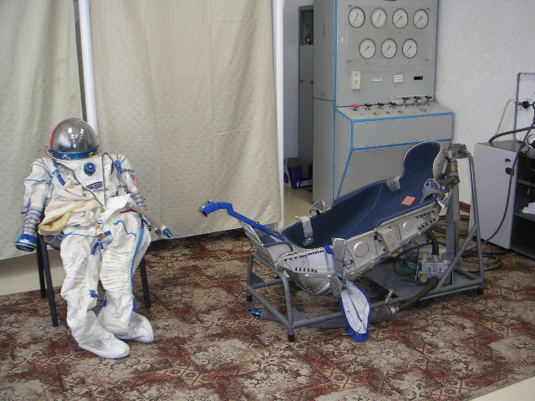
2. Russian Space Suit & Soyuz Seat
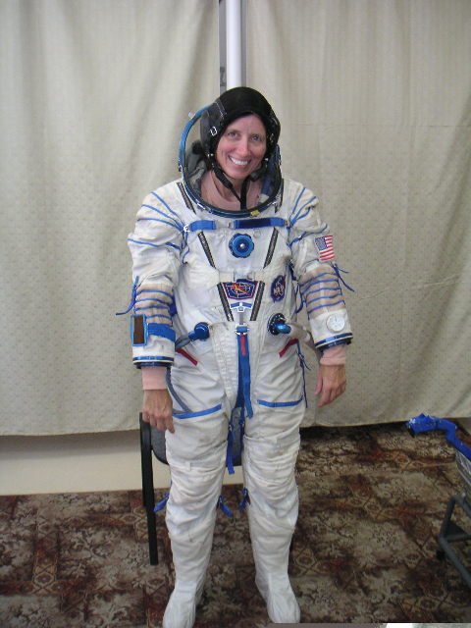
My last class of the day was a structures and mechanisms class. This was a subject that I started the first week I was here. I think I am going to finish up this subject this week.

I started my life support systems test preparation classes on Tuesday. The first lecture of the day was a "seminar." So, that was two hours of me being asked questions about all the different parts on subtleties of the system - the oxygen delivery system, the carbon dioxide removal system, the food, the toilet, the space suits, etc. The life support system is not complicated, but there are a lot of different parts to it. And, just like in the docking system review, the key is figuring out what they are actually asking for in their questions - a general answer or a particular answer. Luckily, I had a very good study session Monday night, and so I was prepared for the onslaught of questions.

Next, I had a practice session in the Soyuz on the interface leak check system. We ran through all the procedures that can be done - checking for leaks and pressurizing or depressurizing various compartments. After lunch I had my "consultation" the interface leak check system. But, since we had just gone over the system right before lunch, there was not much else to discuss. So, we decided to cancel the class so I could use the time as "self-study" in prep for my life support systems test.
The rest of the work day was scheduled to be gym time, so I had a good workout with weights. After dinner I studied (of course - what else?). I actually was as pretty tired, so called it an early night. Well, reasonably early, that meant I stopped studying about 11p rather than my usual midnight.

Wednesday started off pretty good since I had had a very good night's sleep. I had my "consultation" for my life support class. This was more questions and answers. Since, the instructor already knew that I knew the system pretty well, we got into some of the weeds, but it was fun. I may not have pretty answers, but I certainly understand this system.

Unfortunately, after the life support Q&A I had two sessions (i.e., four hours) of Russian language. That just sucked the life out of me. The first class went well, but after lunch, my brain just stopped. Everyone says that you will have "good Russian days" and "bad Russian days." I will put this one in the bad Russian days column. Oh well, what can you do?

Lastly, I had another structures class. I think I am done with the lecture part of the class. Maybe. Tough to say. My evening was a final prep for my test, of course.

Thursday morning was my test. I think it went very well. The test committee for this test was comprised of my life support systems instructor, my suit instructor, my survival kit instructor, my docking systems instructor, the life support hardware owner, and some guy in a military uniform. There were also two people sitting in the back of the room who did not ask any questions. It was quite a crowd. This was actually a fun test. My instructors already knew that I knew the material from the prep classes. So, they were clearly on my side and never asked any questions that were too in the weeds.

At times it got rather silly. The instructors were clearly relaxed. One of them painted the scenario of that we just got on orbit and out of our suits and our underwear is wet - what do I do. I knew the question was really getting at the procedures on drying out your space suit. So, I went through all of that. Then he got a grin on his face and asked what I would do about my underwear (knowing that this is not really part of the standard life support info.) So, I told him that I would hang my underwear out of the window to dry. They all thought that was pretty funny. The test took about an hour and a half.

After the test was done I started two new subjects - the thermal control system and the propulsion system (the engines that you use to maneuver in space). I had one class on each system. Next, I was scheduled for gym time. But, instead of going to the gym, I prepared dinner for the gang. Late last week, I claimed this day for dinner. Since my test was scheduled for the morning and I was starting new subjects, I knew that I was not going to have to study that much this evening. So, I used my gym time to get everything ready. I made lasagna, salad and a chocolate cake. One of THOSE chocolate cakes. Everyone raved about it. The woman who is the commander of the next Station increment and who is scheduled to go up on the next Soyuz flight in mid-October is in Russia now doing her final training. She is a very good cook and provides many of the group dinners. She asked me to make her one of these cakes before she leaves for Kazakhstan and quarantine in two weeks. That is truly a compliment.

On Friday I only had three classes - one on the thermal system and two on the propulsion system. The thermal systems class was very good and the propulsion systems classes were a very long four hours. Unfortunately, the instructor for this subject is not turning out to be one of the better instructors. Oh well. The last period of the day I was scheduled for admin time. But, since I had skipped the gym on Thursday, I used that time to work out. Then we had a group dinner and we watched a movie.

Saturday, we had our weekly pilgrimage to the grocery store and then some of us went gift shopping. There is a particular market on the outskirts of Moscow where a lot of the tourists go to buy Russian trinkets and crafts. I did not need anything, but I went along to have something to do and to get out of the cottage for awhile. Afterwards it was a nap, a workout, dinner, and another movie. Not a bad Saturday.

Sunday was a big study day. Well, a big study and nap day. The weather was just perfect nap weather. And, for whatever reason, no matter how much sleep I get at night, I never feel one hundred percent rested. I have not figured out why that is. I do not have any tests this week, but I am starting a couple new subjects, one of which is considered the most difficult system of the Soyuz - the motion control system. So, I figured it would do me well if I stayed ahead of the reading for the upcoming week.

Weather report - 40's and 50's with drizzle most of the day. One morning I woke up and it was 36 degrees F. Bleah. Not really good weather for anything other than studying and naps.

Soyuz Training — Russia
September 17 - 21, 2007
This week was a lot more difficult than I expected it to be based on my schedule. I did not have any tests scheduled this week, which should have meant that my evenings were not quite so pressured for me to hit the books the entire time. But, somehow it did not turn out that way. And, my classes were wearing. Well, not all of them - some of them were very good, but some of them were quite wearing and those just sucked all my energy. I have been told by those who have been through this type of training in the past, that there are a lot of emotional highs and lows when in Russia. I do not know if it is the weather, the daily schedule, the fact that I am just not at home, or something else, but it does seem to me that it takes more energy to get through a day here than it would to get through a comparable day in Houston. I never feel like I am operating at one hundred percent. It is strange.
At least Monday started off with some good lectures. I had two thermal control systems classes. The instructor for this system is very, very good. After lunch, I started a new topic with a lecture on what is termed optical devices. There a handful of optical devices that the crew will use during the course of a flight to or from the station. The main one is basically a periscope. This device can either look perpendicular to the spacecraft, which allows the crew to use it to get in the right orientation with respect to the Earth. Or, it can look along the spacecraft as an aid for when you are docking with the Station - you line it up with a target on the Station. The other devices are all back up items, such as a laser range finder, to assist with docking should the main systems fail. Think I am now done with all the thermal system lectures, the rest of my classes are either practical sessions or test preparation.
It is interesting; in the thermal control classes I can understand about ninety percent of what the instructor is saying because he speaks clearly, so I can pick out the words I know. Or, I can figure it out even if I don't know the words because he is animated. So, with his gestures so I can follow when some value is rising or falling. But, in the optical devices class I basically understood nothing. I clearly am not familiar with the technical terms associated with these devices. But, also, the instructor is not very animated in speech or gesture, so I have a hard time picking out the few words I know. My last session of the day was admin time.
Tuesday started with a thermal control practical session. We had a very thorough going through of all the indications to and operations by the crew. I quite enjoyed the class. Afterwards, it was another new subject - I started the motion control system. This is supposed to be the most difficult subject as it not only has a lot of information, but it deals with all the calculations that are made in order to move the Soyuz to where you want it to go - how you change your orbit, how you rendezvous with the Station, how you do your deorbit burn, etc. Actually, there are several parts to this topic. There is a part associated with the main computer of the Soyuz, the "digital loop." There is a part associated with the components used should be main computer fail, the "analog loop." And, there are parts associated with the rendezvous phase of flight and parts associated with the descent phase. My classes this week are on the analog loop. Then, as I understand things, after certain number of classes, I will start classes on the digital loop. Apparently, there will be one test that will cover both loops, but I will get two grades, one for each loop. That will be an enormous amount of material on that test.
In the afternoon I had a practical session in the simulator on the optical devices. There was not that much to go over, as the devises are fairly straight forward. But, I did get to try flying the Soyuz a bit. Unfortunately, I was given no practical information on how to actually fly, so I managed to drive the Soyuz through the Station. Good thing it is just computer-generated scenes. . . No real harm done.
The rest of my day was a nap, some time at the gym with weights, and an evening of studying.
Wednesday was a long, long, long day. I had a couple of classes on the propulsion system. This is a subject that I started at the end of the week last week. About the only thing I can say is that I do not see eye-to-eye with my instructor. It is the classes for this system that made this week so hard. That and my Russian classes, which I also had today.
Unfortunately, because of my test last week and the fact that I started four new subjects which meant a lot of reading, I did not get all my Russian homework done. Nor did I get to study my new words very much. So, admittedly, I was not very well prepared. I explained this to my teacher at the beginning of class and she seemed to understand. However, after lunch, when we went over some of my written homework and I had some mistakes in it, I was lectured pretty severely. The way I see things, given all the systems tests I have, I need to put my study emphasis on learning the systems and learning the Russian terminology. Once I start doing simulations, I will have to put an emphasis on communicating. So, on the one hand, my teacher is right in that my language skills are vital to my success in the Soyuz. But, on the other hand, there are only so many hours in the day and I am going to use about a third of them sleeping. Because I was feeling so worn down, I just did not have the wherewithal to take the lecture. It was rather upsetting.
And, finally, at the end of the day I found out that instead of what I thought was going to be a different instructor for a lecture on Thursday on the jets used during entry, I was going to have another propulsion system class with the same instructor. I was so down. But, the gang got together for dinner and that helped my disposition a lot. A little wine and a little whine. . . This was definitely a low day.
Thursday morning was filled with four hours of lecture on the analog loop of the motion control system. So far, so good. The class was not too difficult (yet), but it certainly was a lot of information. After lunch I had my propulsion system class. It was really getting on my nerves. I cannot tell if I have a cultural issue or if the instructor is just grumpy, but I will definitely be happy when this subject training flow is over. As best as I can tell, I have more of the same tomorrow. Sigh. The rest of the day was gym time and study time.
Friday morning was another four hours of analog loop. I was doing great up until about the last thirty minutes. Then my brain was apparently full. Because I do not have all the acronyms down cold, sometimes I could not tell if we were talking about a computing box or an attitude of the spacecraft. Needless to say, that made things a little confusing. Ah, well, I will try and catch up on the weekend.
After lunch I was tortured with another two hours of the propulsion system. It was frustrating. And, I did not appreciate being lectured because I had not read something that I was not told I needed to read and was not part of the subject matter of the class at hand. Eh, what can you do? Lastly, I had a session in the simulator going over off-nominal situations regarding the thermal control system. That was a breath of fresh air.
Friday night we had our typical group dinner and movie.
On Saturday I decided to take a break from studying. I went into Moscow with the athletic trainer that is here working with the crew that is to launch in a couple weeks. Since he has spent virtually no time in the city, I played tour guide and we spent the entire day just walking around looking at the sights. In the evening we met up with the rest of the gang at a very nice (and expensive) steak house. That meal definitely hit the spot.
It was back to the books on Sunday.
Weather report: We had what the Russians translate to us as an Indian summer. In the Russian lore, of course, it is a bit different. For them, the story is that this is a warm spell for an ordinary farm lady. She apparently worked hard all summer doing her harvesting and by the time the harvest was over, the summer was over. However, after the first cold spell there were a few warm days again and she finally got to enjoy some summer. Or, something like that.
What it meant this week is that we had about 36 hours of non-rainy, non-fifty degree weather. I think it actually got back up into the sixties for a short time. I probably should explain that the buildings in Russia are heated via central heat from the city. Until the city turns on the heat, there is no heat, unless you have a space heater (which we have in our cottages in addition to central heat). So, because it has been in the fifties for the last couple of weeks, the buildings are pretty durn chilly. Let us just say that you do not bother to take your jacket off when you are inside. The Indian summer was nice while it lasted, but it did not do anything to warm up the buildings. By the end of the day, I usually cannot feel my feet. . . I am sure that my being cold all day is a significant contributor to my feeling low on energy.
© Shannon Walker 2009
Soyuz Training — Russia
September 24 - 28, 2007
I started a couple new systems on Monday. Well, the first one was sort of new, sort of related. This was the "digital" portion of the motion control system. What this means is that this is the piece of the motion control system that uses the main computer of the Soyuz to conduct its operations. There is a separate computer for the "analog" system (that was the portion of the motion control system that I started last week). I heard my analog loop instructor was out for the next week or so for some reason. So, instead of continuing with the analog system, I am starting the digital system. Whatever. I supposed in the end it will all come together. The instructor for this digital system class is quite young and, apparently, a new instructor. He is very matter of fact, but I think he does a very good job of explaining things, which is good, since this is a very complicated system.
After my motion control class, I had my second new subject with a class on what is termed the on-board measurement system. This is the parts and pieces that collect the telemetry on the hardware (and the voice loops within the spacecraft) and either record the information (the "black box") or send it to the ground.
After lunch I had a prep class for my upcoming thermal system test. We went over a few more items and then we called it a day. I got out of class about an hour early. I was scheduled for gym time afterwards. I went, but first I decided I needed to shut my eyes for a little bit. I thought that maybe I would rest about 30 minutes or so. Well, an hour and a half later I finally woke up. I guess I was tired. . .
We had a group dinner tonight. The crew that is launching in October, and their backup crew, has just a few days left in Russia before they all leave for Baikonur for the final fit checks and quarantine. So, we are doing our best to prepare their "favorite dishes" before they go and not be able to eat them on-orbit. I made some grilled pork tenderloin and a chocolate cake for tonight's dinner.
The crew's flight doctor from Houston came into town this weekend and he brought over flu shots for the folks currently in Star City (normally, I would be given one in our clinic in Houston). Because the commander of this expedition is also the "crew medical officer," we let her practice some of her skill on us. We let her give us our flu shots. She did just fine and now, hopefully, I will be able to avoid the flu this season.
Tuesday morning was a good morning. I had two lectures on the digital loop, but actually the entire time was spent in a mini-trainer punching buttons. The mini-trainer is several PC's strung together with each screen emulating a portion of the Soyuz panels where the crew controls the spacecraft. We went over all the things that we talked about in class yesterday as well several new things.
Afternoon was much better than I expected. I had another one of THOSE classes, i.e., a class on the propulsion system. However, today we were in the simulator running through some procedures. So, other than simulator problems, the class was straight forward and everyone was cordial. Whew! But, it is back in the classroom tomorrow. . .
I supplied a cheesecake for dessert tonight.
Wednesday morning, I had my thermal control system test. I had studied a lot for it on Sunday as well as last night so I felt prepared. I did well. I had some trouble with some of the questions just because I did not understand what they were driving at and not because I did not understand the system. But, we sorted all through it together and I think everyone was happy in the end. I know I was.
After my test I had my usual Wednesday fun of 4 hours of Russian class. I, once again, admitted up front that I had not had any time to do any Russian studies. I am sure my instructor was not happy, but class went better than the previous week. At least I did not receive any lectures. It was still a long 4 hours, though.
I ended day with another class on the propulsion system. Urgh. I feel like these classes are kind of like Moses in the desert. We wander around the topic for a long time before I get a glimpse of the land of milk and honey. It is painful.
Tonight's fare included a key lime pie by yours truly. I think I have been pegged as the dessert person.
Thursday morning was interesting. Today the crew left for Baikonur and the Russian have a going away "breakfast." What this really means is that there is a standard Russian buffet of cheese, meat, tomatoes, cucumbers, dill, vodka, champagne, wine, and water. All the big wheels are there and they make a bunch of toasts. I opted for water as it was 8 in the morning and I had a full day of classes. After the "breakfast" the crew troops outside for some pictures (made underneath a statue of Lenin) and then they get on the bus to head to the airport.
After the morning ceremonies, I had four hours of motion control digital system classes. So far, it still seems all comprehensible. My afternoon was four hours of preparation for the propulsion system test. It was ugly, ugly, ugly. I felt like an idiot because I did not know the system like I would have preferred, but on the other hand, many things I was asked had not been taught and/or they were not in my training manuals. I am just counting the days until this particular training flow is done.
Friday, I had a short day. I had one class on the digital motion control system. And, then, I had a final propulsion system preparation class. In the afternoon, I was scheduled for my weekly admin time and my other weekly gym time. I had the schedule arranged like this on purpose because today I bugged out of town. I went to Amsterdam! Andy had some meetings there with the European Space Agency folks this week and we decided to take advantage and spend some time together over the weekend. It was a very nice break from all my classes, to say the least. (Note from Webmaster. . . Andy is Shannon's husband.)
The weather was actually worse in Amsterdam than when I left Moscow (go figure). This past week the "Indian Summer" returned and it has been warm (a relative term, mind you) and sunny in Moscow. It was 50ish and overcast or raining the whole time I was in Amsterdam. But, that didn't matter. We had a great 36 hours together. We rode boats up and down the canals. We walked the city. We ate in good restaurants. We almost made it to the Van Gough Museum, but the line was way too long and we did not feel like standing in it in the rain. So, we opted for some wine and cheese back at the hotel instead.
And, then the weekend was over and I went back to Russia. I had probably the worst time I have ever had at the airport. It took, literally, two and a half hours to get through passport control. That was insane. I think their computer system must have been bogged down or something. I could not tell any other reason as to why it was taking so long. After that, there was a huge traffic jam leaving the airport. I got back to my cottage at 10:00 pm. So much for spending the evening doing some studying. By the time I got back, all I did was have a snack and go to bed.
© Shannon Walker 2009

Soyuz Training — Russia
October 1 - 5, 2007
Monday morning was a full slate of motion control classes. I first had a class of lecture and then a class of working with the mini-simulator. Instructor asks a lot of detailed questions of what we have gone over in the past. In a perfect world, I would be able to keep up with all the reading and know everything. But, this isn't a perfect world and his is not the only class I am taking. So, even though he may not be happy because I cannot answer every single last question (though, I do get a large number of them right), I very much like the review of the material.
In the afternoon I started a new system - the electrical power system. I have the same instructor as I had for my docking system class. I am glad - he is very straight forward and rather entertaining.
For my last timeslot of the day I had gym time scheduled. Unfortunately, I could not muster the gumption to go work out. I took a short nap instead. Then I hit the books.
In the evening spent a lot of time studying for my propulsion system test, which is on Thursday. I feel like the propulsion class is putting me behind in my other classes. I am spending so much more time studying this system compared to the other systems because I am having to do so much learning on my own. I will definitely be glad to have the test behind me.
I ended up studying late into the night Monday night to try and keep up with all my classes. Consequently, felt sluggish when I got up Tuesday morning. But, I mushed on and had four more hours of the motion control system. The instructor packed lots of information into class today. Luckily, though, the instructor continues to be very clear in his explanations, so I do not have a very hard time following the information. Not sure I will remember it all after today, since we covered so much, but at least I have a good basis by which to start studying.
In the afternoon I had an electrical power class. We had fun, which was good, since I was starting to get pretty tired. Then I was scheduled for admin time. I used it to do a little Russian homework for a change. It was probably not enough for my Russian teacher's satisfaction, but it was better than nothing. Then, sort of went into panic mode over my upcoming test. Yesterday I thought I had a good understanding of the system. Today, looking at some of the actual exam questions that have been asked in the past, I was not so sure.
Wednesday started with an electrical power systems class. Then I had my usual four hours of Russian. The instructor seemed happy with the amount of homework I had done. I certainly did not complete all of what had been assigned, but it must have been enough as I was not scolded for not doing more.
Wednesday evening was quite different from my usual evenings. There was a reception at the American Ambassador's house. All the NASA folks in Moscow and Star City were invited. The reason for the reception was that it is the fiftieth anniversary of the launch of the Sputnik satellite and the two hundredth year of diplomatic relations between Russia and the United States. I did not know that second bit until I got to the party. At the ceremonial part of the party, the NASA administrator and his Russian counterpart signed more agreements for additional cooperative projects in the space arena. The ones signed today had to do with joint scientific studies on the Moon and Mars. It was all very nice. Because my propulsion system test was the next day, I reviewed my notes on the drive over, and then I enjoyed myself with the snacks and party atmosphere. I hit the sack when I got back. I figured at that point either I knew the system or I did not and another hour of studying was probably not going to make a difference.
First thing Thursday morning was my dreaded test. It was a very interesting affair. This test, by far, had the largest number of people in the room asking questions. There was the system expert and my instructor, of course. And, there were instructors from the motion control systems area, there were a handful of management types and there were some people there who I think just came to see the show. The test was definitely not easy at all. There were times, just like on my other tests when I could not actually tell what the heck they were really asking. And, there were times when I would give an answer, then the questioner would launch into some discussion and I would be thinking to myself, "Did I not just say that?" The Russian examiners seem to put a high value on rote answers to certain questions.
In the end, it seemed to me that the test sort of ended up being a food fight between various instructors. The problem was that the propulsion system is just the effector of the motion control system. I am just now having motion control classes. So, my knowledge/understanding of the propulsion system (tanks, valves, engines, sensors, etc.) was quite good because I was able to sort through that system myself. My knowledge of how the system interacts with the motion control system was not as good, since I have not had all the classes on that system. But, that did not stop the old, storied digital loop motion control instructor (whom I do not have), from asking questions about his system. At any rate, after it was over, I was sent out of the room and the instructors got after one another. I could hear some of it through the door. Apparently the propulsion instructor had told me something wrong about the analog loop of the motion control system and the motion control instructor did not like the fact that the propulsion instructor was treading on the ground of the motion control instructors. And, it seemed to go downhill from there.
After all was said and done, I got an excellent on the propulsion system and a "we will wait to assess" on the motion control interactions with said propulsion system. I reckon I can live with that.
As soon as that fun was over, I started classes on the communications system. I had two lectures in that class. It seemed straight forward, but then again, the instructor did not ask any questions of me - so it could be that I only think I understand things. One thing that I think is interesting that is during the landing the Soyuz capsule automatically sends out beacon signal for the search and rescue folks to track you by. While that is not too surprising, once the capsule hits the ground the signal changes from a Morse code type signal to something that the Russians call the "Call of the Seagull." It actually sounds like the sound that a seagull makes. The change in the signal lets the rescue crew know you are on the ground, but why a seagull sound, I do not know.
Then came my last lecture of the day - electrical power. By then my brain was tired and I could not remember many of the things that we had discussed the day before. It was not my best showing in a class. Tomorrow I have an exam prep class in this subject and, I think, the test will be on Monday. So, no rest for the weary. It was back to the books again in the evening.
I thought Friday was going to be a better day than it turned out to be. I had studied a lot the night before, but, it seemed as though my motion control instructor only asked questions on the few parts that I had not been able to review. That was just annoying. At least the afternoon was better. I managed to pull together a respectable showing in my electrical power systems class. And, we covered all the material that we were slated to cover fairly quickly, so we ended the class early. A rare occurrence indeed. As we were leaving the electrical power systems class, we ran into the instructor for my last class of the day (communications systems) Luck was with me and we were able to start that class early. So, I finished my week about an hour earlier than was scheduled. That was nice because it had been a long week.
On Saturday I went into Moscow to hang out with a friend who was on her first trip here. Unfortunately, it was a rainy day. Not at all good for souvenir shopping or seeing Red Square. We were finally forced to give up tootling around and sit in a restaurant and watch it rain. I guess that was not so bad.
Sunday was my usual catch up on sleep and study day.
© Shannon Walker 2009

Soyuz Training — Russia
October 8 - 12, 2007
Monday was Columbus Day holiday in the States. Obviously, that is not a holiday that the Russians celebrate, so no holiday for me. The week started off with four hours of motion control lectures in the morning. We continued to go through all the different types of maneuvers that are done and how they are accomplished. Each class we start with a brief review/question session of what we have covered recently and then we add to it. It is a good approach since this system is so complicated.
In the afternoon I actually had my first class on the Space Station. I had had a Service Module class. The Service Module is the main Russian segment on the Station. It is the location where the Russian cosmonauts sleep, where the crew gathers to eat, where the toilet is, where the exercise treadmill is, where the atmosphere scrubbing equipment is, and where the computers are that control the Russian side of the Station. So, most of the guts of the Russian segment is in the Service Module.
This class was held in the main Station mockup and we went through a high level discussion of all the equipment and their locations on the Service Module - both inside it and on the outside. It was actually pretty nifty. For all the years that I worked in the Station Program, I heard so much about all this hardware. And, we have our mockups and simulators in the U.S. But, today, instead of seeing a picture or working with the U.S. version of the hardware (very rudimentary), I got to see the high fidelity models that the Russians use. I enjoyed it.
I think I need some water proofing goo for my shoes. I wonder if I can get that here. It has been raining so often that there are puddles everywhere. My shoes get soaked through and my toes get wet when I am walking to class. That definitely does not help keep my feet warm.
I asked folks here how the decision is made by the powers that be to turn on the heat in the buildings. What I was told was that there is some formula that is used along the lines of the temperature has to be below a certain level for a certain number of days in a row. Once that happens, then cold weather is considered to have arrived for the year and the heat is turned on. I do not know what the temperature is or how many days that it needs to be at that temperature. I do know that it is still chilly in my classrooms.
The rest of my day was gym time and study. Plus a little goofing off. There are lots of folks from NASA coming and going this week because of the Soyuz launch on Wednesday. So, there were some folks in town that I have not seen in awhile and we had a group dinner together. Then I hit the books for my test on Wednesday.
Tuesday morning was another four hours of motion control. Apparently next week will be the first time we do motion control stuff in the simulator. So, today the instructor did a huge review of everything we have covered so far as part of the preparation work for the simulator session. Except for not knowing a couple of the acronyms in Russian (I knew what they were in English), I felt like I knew everything he went over today. That is good, because that means I have been able to keep up with this complicated and information packed system.
In the afternoon I had a practical session in the simulator working with the communications systems. It was very straightforward. Afterwards, I spent some time with the treadmill in the gym and then I spent the evening polishing my electrical power system knowledge.
It was a bit colder today. You can feel it in the air - even though it is still 50ish (or a little below) and raining, the air has a cold bite.
I had my electrical power systems test first thing Wednesday morning. It went well. I was pleased and so was my instructor. After that, since the test was only scheduled for an hour (took about 40 minutes), I had a second class squeezed into my 2 hour block. This one was a mini-motion control seminar. In some ways, it was kind of like having a second test. I spent an hour being asked questions by the instructor. Then I had Russian class. Sigh. Still just mushing along with it. Still not having enough time to do much homework. Still a long four hours.
Afterwards, I did a very shortened gym workout and then I watched the Soyuz launch. The NASA IT folks have managed to somehow have NASA TV piped over with the Armed Forces Network TV that we get. The launch was very nifty. It was nice to be able to understand some of what they ground was talking about with the crew. After that, I mostly goofed off. I did a little reading, but not too much.
Thursday was an interesting morning. I had a class on the Soyuz "panels." This is a class that I would have had at the beginning of my time here, had the instructor been available. I do not even remember now why he was not able to teach the class then. The class went over all the ways that the crew can interact with the Soyuz systems - how you get data to and from the computers, what information is shown on all the displays, etc. So, I went back to the basics. But, it was a thorough class and I am definitely getting more information than I have picked up about the various displays in my other classes. I learned some of the subtleties and/or gee whiz aspects.
In the afternoon I had classes on the Soyuz TV system. That, too, is very straight forward system.
It was really cold today. The outside temperatures were in the upper 30's. I could not wear enough layers to keep warm in my classes. Plus, they are replacing the radiators in many of the rooms, so, at the moment, they could not have heat if they wanted to.
I did not study at all tonight. There was a reasonable amount of family and friends in Star City because of the launch. It is interesting, but the Russians tend to make a bigger deal out of the Soyuz docking with the Station rather than its launch. It is almost considered to be bad luck to celebrate before the crew gets to where they need to be. The docking is two days after the launch, so many of the guests that went to the launch hang around until the docking since that is when all the official ceremonies are. We had a group dinner and then we spent some social time together.
TGIF! I started off with a motion control session in the mini-trainer as prep work for the real simulator next week. It was a good, if not frustrating, session. The instructor asked a lot of questions, which is fine. But, half the time I could not figure out what exactly he was asking (yes, I know that is a common theme with me). I felt like telling him at one point that if he does not raise the flag to indicate he is changing subject, I will have a hard time following him. And, if I tell him I do not understand the question, that does not mean I do not know the answer, it means I do not understand the question, so do not keep repeating the same words to me. Rephrase the question so I know what you are asking. I think he was frustrated also. Oh well.
Next, I had a practical session in the Soyuz simulator going over the panels. It was good. It would have been better at the start of my trip, but now is better than never. In the afternoon I was supposed to be back in the simulator going over the TV system. But, apparently there was a scheduling conflict and someone else was using the simulator. So, the class was canceled. We were able to dig up the instructor for the last class of the day and, luckily, he was free. So, I was able to finish up the day early. My last class was another Station Service Module class on its composition and construction.
Because I got done early, I was able to go with the folks to the Control Center and watch the docking. That was fun. Normally, NASA has a party out in Star City after docking. However, because the actual docking was so late in the evening, the usual management and others in town did not come out to Star City. So, after we got back from the Control Center, those of us staying here just did our usual hanging out and watching a movie. On Saturday I spent a lot of time in the gym doing cardio exercise while watching TV. It was fun. Then we had our usual trip to the grocery store and a group dinner. It was a typical Saturday - nice and relaxing. Sunday was a study day. Not too much studying, but enough (well, hopefully, enough). We actually had our first snow today. It started out raining in the morning and, it actually felt warmer than it was yesterday. But, at some point the rain turned to snow and snowed the rest of the day. Brrr.
Seven weeks down, five to go. . .
© Shannon Walker 2009

Soyuz Training — Russia
October 15 - 19, 2007
Well, I managed to come down with something during the night Sunday night. I woke up Monday with a sore throat and feeling puny. So, I cancelled my morning classes and went back to sleep, hoping to nip whatever it was in the bud. By the time my afternoon classes rolled around, I was feeling better, not great, but better. I was glad that I was able to do go to my afternoon classes since I was scheduled for four hours in the simulator running motion control procedures. Trying to reschedule such a large block of simulator time isn’t easy. It actually turned out to be quite a good class. It definitely helped solidify what we have been talking about for so many weeks. The classes that I missed this morning were rescheduled to be during my gym and admin time later this week.
All the Russians were very concerned about me and clucking over me like mother hens. It was sweet. Even one of the drivers who works for NASA and who also acts as our resident handyman came by this evening to make sure my cottage was warm enough.
I spent my evening spent laying low and trying to get healthy. I did a little studying, but pretty much called it an early night.
Tuesday I was still feeling under the weather and I had definite heat issues, namely, there still is not any in the classrooms. Obviously, that is not good for trying to recover from being sick. My management is trying to work something out with the Russians so that I can at least have portable heaters in my classrooms to take the chill off. My morning was four hours of motion control. We are still packing in the knowledge.
In the afternoon I had my first test prep class for my test on Thursday. This test is going to be over the onboard complex control system (I had classes on this subject at the very beginning of this trip) and "panels." The classroom was very, very cold. Luckily, the class ended early. And then I had another class on the Service Module composition. This class was also cold. By the end of the day, I was pretty well worn out because of being so chilly in the afternoon. I had to sleep awhile to recover. Mind you, it is not as if I am wearing tank tops and flip-flops to class. My usual outfit is something along the lines of a shirt, a sweater, pants, long johns under my pants, two pairs of socks (one of which are my "smart wool" thick camping socks) and my jacket. Unfortunately, being cold is definitely affecting my ability to get well. And, being under the weather is affecting my ability to study. Not good.
On Wednesday it seemed as though that they have finally turned on the heat in some of the rooms in the building that I have most of my classes. Other rooms are still having their radiators replaced. So, my first class of the day was a bit warmer - definitely not toasty, but not freezing. Though, I still wore my jacket the whole time. This class was the final prep class for my test tomorrow. The classroom where my Russian lesson was to be held had no heat (or radiators), so I ended up having my lesson in my cottage. Then, it was back to the training building for my last lesson. It was in a different room and this room was a bit warmer than the other room - not shirt-sleeve weather, but I did not have wear my jacket the entire time.
I am still slowly recovering from whatever illness that I have. I hit the books in the evening and then hit the sack early to try and get a good night's sleep.
My test was first thing in the morning. It was definitely not my best showing. Someone, presumably a wrong number, called one of the phone lines in the cottage at 6:00 a.m. I stumbled out of bed to answer the phone, but no one replied. They called back about 15 minutes later. I just let the phone ring at that point, but I never did manage to get back to sleep. So, I was rather tired and not feeling well at all. My test ended up being in a cold room, which was not good either. Surprisingly, no one from the designer world showed up for the test. So, it was just my instructors asking questions. One of them asked a lot of really detailed questions on things that we never discussed. I have to admit that I struggled with some of the questions, but we muddled through. The other instructor, thankfully, did not ask anything too difficult. In the end, I think that they could tell that I just was not myself. So, they wrapped things up, probably took pity on me, and said that I did just fine.
The rest of my day was motion control and more motion control, with a small break from that with a television systems class. It was the make-up class from Monday.
Friday, you guessed it, I had four more hours of motion control lectures. We mostly reviewed things and that was good. The gargantuan test for this subject is marching ever closer. Actually, I think I have had my last lecture in this subcategory of the motion control system. I still have the "analog" side to finish, and the test prep reviews, but I think (I hope) we have gone through all the material for the digital side of the house. In the last couple of days, we have covered about a bazillion different algorithms that the software uses to monitor various things - how the maneuvers are going, how the equipment is operating, etc. Needless to say, it is a lot to remember.
My last class of the week was a test prep class on the comm. system. I was supposed to have a test prep class on the television system as well, but it turned out that my instructor had to do military duty. So he was unavailable and my last class was cancelled. That was just fine with me. I did not mind at all having a free period at the end of this week.
I used my free time to move my things to a different cottage. We have some folks coming in for training this weekend and they normally stay in the cottage that I had been staying in. The whole issue of who stays where when is a delicate dance that I am glad that I do not have to sort out. For the most part, they try and have us stay in the same cottage and bedroom for consistency. Traveling back and forth can be hard enough without feeling like you are a hobo the whole time you are here. Being the low person on the training totem pole, I will be doing any moving required to accommodate those that are closer to their flight. I moved into the cottage/bedroom which had been previously occupied by the lady that just launched on the Soyuz. Obviously, she will not be around here for the next six months, so, perhaps, I will be able to stay put for the time being.
My weekend was fairly low key. I did not do much of anything on Saturday. We had our usual grocery store run and that is always good for taking up a couple of hours. The rest of the day I pretended to study, but I was not too motivated. We had a group dinner and we watched a movie. Sunday was my usual catch up on sleep and study day. And, thankfully, I finally started feeling like my old self on Sunday.
The returning Soyuz crew landed on Sunday. I was able to watch it on NASA TV. They ended up having a slightly off-nominal entry. For some reason the capsule went into what is called ballistic mode. It is not clear why just yet. But, basically, if the computer detects any off-nominal indications from the sensors feeding it data, then it will downgrade the entry to ballistic. What happens is that instead of having a "nice, gentle" entry through the atmosphere, the capsule starts to spin. The spinning makes it very stable coming through the atmosphere. Basically, the computer says that it is not going to listen to the sensors anymore, and, thus, the capsule spins so the computer does not have to try to keep the capsule on track. In the ballistic case, the trajectory in which the capsule comes through the atmosphere is slightly steeper than the nominal case. So, the crew actually ends up experiencing eight or nine g's rather than the nominal three or four. Even though it is a very safe entry, it is definitely not quite as much fun after you have been on-orbit for six months. Because this is a "nominal" "off-nominal" situation, the Russians have backup helicopters and doctors to meet the crew at the ballistic landing site. It is the equivalent of the Shuttle landing in California instead of Florida.
Once the crew is out of the capsule (for either a nominal entry or a ballistic one) the doctors look them over and then they are flown back to Star City. They usually arrive back in Star City about eight hours after they land. It is a pretty amazing process considering that they land out of the middle of nowhere in Kazakhstan. The crew is put into quarantine since the doctors want to keep checking on them and the doctors collect their usual data and specimens. The building where the crew stays in quarantine is right next to the NASA cottages. In fact, our flight doctors live in that same building.
When the crew gets back to Star City there is a very brief celebration. The crew arrives on a bus. As it pulls up to the quarantine building, a small military band plays a tune, the crew is greeted with flowers, people clap, and then the crew is whisked off inside. Currently there are only about half a dozen folks from NASA in Star City. But we all went out and cheered their arrival. They were looking pretty good for having just been in space for six months. I hope I look as good if I have that ride back.
© Shannon Walker 2009

Soyuz Training — Russia
October 22 - 26, 2007
Monday, I started back in with the analog portion of the motion control system. This was the part of the system that I had classes on a month ago. I figured that the instructor would have had a short review, but he did not. He just jumped right in and provided me with a flood of new information. Let's just say that since I had not closely looked at the material in four weeks, I was not up to speed the subject. It was a whirlwind four hours.
In the afternoon I had a class on the Service Module composition and construction. As it turns out, there were training meetings last week between all the international partner training managers. Because of these meetings my "training flow" (i.e., the amount of stuff I have to know) is going to be reduced for this particular subject. NASA has been working extensively with the Russians to try and reduce the amount of time that crews spend in training outside of their home country. They want us to be able to stay at home as much as possible. So, in cases where the crew make up looks like you will have two of one nationality and one of the other (for a three-person crew), then the one person does not have to become as proficient in the hardware and software of the segment that they do not belong to. For example, if I end up flying with two Russians, then I do not need to be an expert on all the Russian systems. There are some things that I will need to have a certain amount of depth on, but if there are problems with something, it would be up to the Russians to do any in depth troubleshooting or repairs. So, by going to a concept of "users" and "specialists" on the various systems, we can cut down the training when you only need to be a user. That is what happened in this case.
However, because it is expected that I will be launching on a Soyuz in the "co-pilot" seat, I will not see much benefit from these types of reductions. The training I am doing now to be qualified to launch in the Soyuz in this role is on the order of six or seven months long and it has to be done in Russia as it is their launch vehicle. In fact, I got the expected schedule for my training next year and the plan is for me to spend thirty-two weeks of next year in Russia. But, the good news is that I will be in Houston for most of April and all of October, so I should be there for the good weather we have then. At any rate, for the Service Module composition and construction training, my schedule this week was cut back from ten more hours on the subject to four. The schedulers put a new subject in its place, so, no free time for me.
After my Service Module class, I had the test prep class on the television system that had been canceled Friday afternoon.
I ended up staying up way too late studying for my tests tomorrow. Actually, do not really know where the time went. I was talking with a fellow astronaut and one of the Russian training integrators on the subtleties of the systems and all of a sudden it was 11:30 p.m. I wrapped up my studying as best as I could, but I still got to sleep about an hour after I wanted to.
Tuesday morning, I had two tests - one on the communication system and one on the television system. The testing committee, however, was the same, for both of them. It was a bigger crowd than I had expected; there were about six people asking questions. There was a slightly different approach to these tests than other tests. It was still oral and still with the folks from the designers, your instructors, and whomever else decided that they need to stop by and ask questions (it was the head of the comm./TV training department and the "old guard" comm. instructor today), but instead of just starting in with questions, you have "tickets." Basically, there are different sets of questions on several slips of paper (tickets, in Russian) and you randomly pick one. Whichever questions are on the ticket are the questions that you have to answer. Plus, any others that they feel like adding on, of course. After each exam they sent me out of the room. This was a bit unsettling as I thought they only did that if you had a borderline performance. Luckily, this was not the case and I passed with excellent grades.
I had motion control the rest of the day. Six hours. Urgh. It was a lot. We spent two hours learning new material; two hours reviewing for the upcoming test (which my instructor took great joy in pointing out that it will be in sixteen days), and two hours in the simulator going over the basics with regard to this portion of the motion control system. After my two tests and my lack of sleep, by the end of the day, my brain was fried.
I took short break and then went to the gym. Afterwards, we gathered together to watch the Shuttle launch on TV. Then I made an attempt at Russian homework and reviewing motion control information, but I was not all that enthusiastic about it.
Wednesday was a typical Wednesday: draining. Two hours of motion control test prep, then four hours of Russian, then two more hours of motion control. In the motion control classes, the instructor and I just were not in sync. It was rough. My Russian class was in my cottage again due to the continuing lack of heat and the ongoing, noisy installation of radiators in that part of the building. I made it an early night.
Thursday: what a difference a good night's sleep makes. I felt so much better today. In the morning I had four hours of motion control in the simulator. It was really good. I was in sync with the instructor. And, I felt like I understood the procedures. I could even answer most of the questions the instructor asked as we were going through the procedures. Maybe I am finally getting a hang of this part of the motions control system. During this class I did some manual flying of the Soyuz. I think I even got a little better at it. I was certainly better than the first time I flew it. It is still not entirely intuitive, but I am getting faster at thinking through which inputs I need to make to have the Soyuz go where I want. It was fun.
In the afternoon just had one class. Because of the re-do of my schedule early in the week, I was given a gym session today. I did not have any gym time scheduled in the original schedule. My one afternoon class was a practical go through of all of the equipment in the Service Module in the Service Module trainer. Then I went and had a great workout. My evening was spent doing my usual studying (or study procrastination as the case may be. . .).
Friday morning, I had a very torturous review of the digital portion of the motion control system. The instructor kept asking me things like what is the most important thing about xyz. It did not matter how many things I could relate about xyz, I never seemed to pick out what he considered to be the most important. "Yes, you are right, but you should have said this. . ."
After that, I started a new Station system - the computer system. These classes were not bad at all since I am fairly familiar with the Russian side of the Station due to my job before being selected as an astronaut. So, not much was new to me (except the Russian acronyms). I cannot say that I was not glad when the week was over, though.
It was a typical weekend - goof off and grocery shop on Saturday and catch up on sleep and study on Sunday. Russia ended their daylight savings this weekend. Our days are getting noticeably shorter now. I checked the web and at the start of the week, sunrise was at about 8:15 a.m. and sunset was at just past 6:00 p.m. - roughly 9 hours and 45 minutes of daylight. By the end of the week, the day's length was 20 minutes shorter. However, because of going off of daylight savings, the sunset is now before 5:00 p.m. Remember, my classes do not get out until 6:00 p.m. Urgh.
© Shannon Walker 2009

Soyuz Training — Russia
October 29 - November 2, 2007

My Monday actually started off with an admin period. That was nice. No need to rush into the week. I used the time in the gym. And then I started two new subjects - launch escape system and landing aids. These are the sets of equipment that are going to get the capsule to the ground should there be a problem during a launch. Basically, the capsule where the crew is separates from the rest of the rocket that is trying to get the capsule in space. Then, smaller rockets take the capsule up to a high enough altitude so that the parachute system (which is used during a regular landing) can then operate. I know it sounds dicey, but there has been one occasion in the distant past where this system was put into use and everything turned out the way it was supposed to. The crew got to the ground safely when their launch rocket exploded. That is actually comforting that it does not just work on paper, but it actually works.
My last class of the day was a motion control systems review. I evidently did not study what the instructor had expected me to and we were having another one of those days where we were not in sync, so it was a very trying class. I felt mentally beat up afterwards. It did not help that it was quite dark when we were done. Somehow, having that extra hour yesterday when we went off daylight savings did not translate into feeling like we were better off today. When we were done at 6:00 it definitely felt like we had gone until 7:00.
Tuesday turned out to be a much better day today in the motion control world, which was surprising because I was up fairly late the night before studying. I know I did not have enough sleep. But, we were in the simulator all morning and things were falling into place. Actually, I have no idea how my instructor felt, but I felt like things were going well. Eight days until the dreaded test on this subject.
In the afternoon I had a practical class on using the laptops in the Russian segment to interact with the hardware systems. It was a pretty basic class, and because the American designers worked extensively with the Russian designers on having consistency between the two halves of the Station, it is not all that hard to figure out. Other than not recognizing some of the words in Russian that are on the buttons that you click, it is fairly straightforward. My last period of the day was gym time. I had a good work out and then I hit the books again.
Wednesday was not nearly as bad of a day as I had expected, being a Wednesday and being that I stayed up quite late studying. My first class was more review of the analog portion of the motion control system. I felt like it went well. I knew a lot of the answers to the questions I was asked. My studying last night paid off. Then I had Russian and it was not as draining as it usually is. I think my Russian teacher and I have finally reached an unspoken agreement that I simply do not have the luxury of devoting as much time to Russian study as either one of us would like.
For my last class of the day I had a practical session on some of the landing equipment that we went over in class on Monday, namely the seat that we ride in and how to prepare it before you leave the station. The seat actually has a shock absorber built into its frame that collapses when you hit the ground. To be accurate, the general plan is that with the parachute and the small landing rockets that fire right before you reach the ground, the shock absorber should not end up being compressed. But, if you end up reaching the ground at a faster rate than is expected, then the shock absorber is there to take up some of the force.
After we played with the seat for awhile, we then we went over some of the questions that are likely to appear on my test on this subject on Friday. In the evening I again stayed up late studying. I am really trying hard to know the motion control system well as it is sort of the standard by which the astronauts/cosmonauts are judged. If I do well on this test, then the instructors know that I am a worthy person to fly on the Soyuz. So, not only is it important because it is such a crucial system, it is important because my performance on this test will pretty much set the tone with the instructors for the rest of my training.
Today was Halloween. Granted it is not an occasion celebrated by Russians, but the local kids know that Americans celebrate it, so they come by and trick or treat. All of us in town had dinner together, so the kids just had one location to go. But, they came by a couple of times and we gave them candy. It was kind of cute.
Thursday was quite a mental workout. The first class period was test prep for the analog portion of the motion control system. Two hours of questions. The second class was test prep for the digital portion of the motion control system. Two more hours of questions. The third class was test prep on the launch escape system and the landing aids. Luckily, this class did not go the full two hours. After all that questioning I was mentally drained. Thankfully, I had gym time scheduled for the last period. I did go, but I had a nap first. All the staying up late this week to study was catching up with me. After the gym break and dinner, it was back to the books, of course.
Friday was another big day of questioning. The first thing I had was more motion control test prep. For this round, however, the digital and analog portions were together and the instructor invited other instructors to join us. So, it was much more serious than other test prep sessions. It was pretty much like taking the test. The only thing missing were the designers there asking questions. The instructors even had me sit at the front of the room as that is where I will be for the real test. My two instructors fired questions at me for about an hour and a half straight. The other folks in the room chimed in with a question or two every once in a while. I felt good because I was able to confidently answer most of the questions correctly. But not quite all of them. And, I still do not answer them exactly the way that they want me to, but I was pleased with how things went. Though, I know I still have a lot of studying to do, but after last night I feel much better about my knowledge than I did yesterday. My nap yesterday refreshed me and I ended up staying up VERY late trying to get the random bits of information that I know about the system organized in my mind. Later in the day I heard from one of the Russian training integrators that the instructors were satisfied with how I did. That is a relief.
Unfortunately, my test has been moved from next Wednesday to next Friday. Apparently, there is a schedule conflict with one of the instructors. On the one hand, that means more time to study, but on the other hand it means more time to fret. I am just ready to have it over with.
After the motion control

© Shannon Walker 2009

Soyuz Training — Russia
November 5 - 9, 2007

Monday was actually a holiday in Russia. To be honest, I am not even sure what the holiday was, but it was nice to have a day off. I asked about it, but the explanation was rather fuzzy - something to do with an event during the revolution in 1917 that actually occurred in the month of September (or, maybe October) and something to do with an event that occurred back in 1612 when the Romanov ruling family was put into power. I just stayed inside and studied (what else?), but it was nice to not have to go to class. But, I did not have to study with quite the intensity that I normally would have over a two-day weekend since I had three days.

I realized that I have not gone outside since Saturday. The current cottage I am in has the gym in the basement, so I do not have to leave the house to get to the gym. Shep's is in the adjoining basement; so, I do not have to go outside to watch movies with the gang. And, the central gathering place for group dinners is in the adjoining cottage. I can just go through the basement to get there. It was a rather grey day today anyway, so the weather did not inspire me to leave the cottage. As a diversion from studying I made spaghetti for dinner for the folks in town.

Tuesday was one last day of motion control test prep. Two hours with each instructor. My digital loop instructor finally admitted that I was ready for the test. Whew! Now, if I can just hold that knowledge in my brain until Friday. . .

In the afternoon I started a new subject. This one is on the radio location system that is used to guide the Soyuz to the Station. Both the Station and the Soyuz have antennas, transmitters, and receivers and between all of the hardware, the Soyuz is able to lock onto a signal from the Station and figure out which way it needs to go to dock automatically. While the system in general is pretty nifty, the class itself was very much in the weeds of theory and math that I am hoping that I do not really need to know.

My last period of the day was gym time, so that is what I did. In the evening I took a break from studying motion control. My friend, Suni, who spent about seven months on the Space Station this year, came into town. She is here to participate in some debriefs with the Russians as her Russian crewmates just returned to Earth last month. So, we spent some time catching up.

I had more on the radio location system on Wednesday. The class was more weedy theory as well as a little practical information. Then I had my usual Russian fun. At the end of the day I had an admin period scheduled. I took a break and then went back to my motion control books to try and finalize my knowledge. The Shuttle landed tonight, so I also took a short break to watch that. I noticed today that the pond behind the cottages is mostly frozen over. The rest of the snow from this weekend is slowly subliming away, but the sidewalks are still quite slippery.
Thursday, I started the rendezvous part of the Soyuz motion control system. The classes I had were very theoretical on how one calculates the size and times of the engine firings to get the Soyuz from the orbit it is in after its launch to a point where you can dock with the Station. However, having had a lot of this type of math and information in school and also knowing how the Shuttle performs a rendezvous and having been around the space business for twenty years, it was all quite familiar to me. So, much to the instructor's surprise, the classes went very quickly as he did not have to spend a lot of time explaining the nitty gritty to me. I will definitely be in trouble if I have to cough up any math on the rendezvous exam, but conceptually the information we covered today was very straight forward. Physics is physics and orbital mechanics is orbital mechanics. The only question is how you implement your equations in your computer. It was kind of fun.

In the afternoon I caught a little break. My Russian training integrator cut a deal with my afternoon's instructor. I was to start a new subject - the panels and composition of two more modules of the Russian side of the Station. But, since I some have familiarity already with the modules and because I will see everything again in other classes, the instructor agreed to let me do self-study for my motion control test. (This test is universally understood among instructors as The Big One). So, self-study I did.

But, I had a few interruptions. This afternoon was the official welcome home ceremony for the Expedition 15 crew. It is kind of neat what the Russians do. The crew first puts flowers at the base of the statue of Yuri Gagarin (first person in space). This statue is at one end of the main boulevard in Star City. While they are doing this and doing some photo ops, there is a military band that plays. In my opinion the song that was played was rather dirge-like. I found out later on that this particular composition was created for the funeral of Yuri Gagarin. Because this takes place outside, one of the stray dogs took exception to the band and barked the entire time at the drummer. Or, maybe the dog was singing along. . .

Afterwards, there is sort of a mini-parade. The crew walks a couple hundred yards to an auditorium. The band follows them and plays. At least this time it was a little snappier tune. On one side of the route there are all the instructors and other supporting folks who are in the military in formation. The rest of us and the locals are on the other side of the route. After the crew and band passes everyone joins in the parade. Once at the auditorium, there are the formal speeches and toasts that go with the standard Russian ceremony/party. I did not stay for the speeches. After the parade I returned to my studies.

I have attached a couple pictures. I tried to get more, but my camera was too cold and the battery would not operate. It was about 28 deg F (or something just below freezing - this took place at 4:00, by the way, the warmest part of the day, theoretically). First picture is the band, the statue and the dog (lower right corner). Second is a shot of the front of the building with the auditorium. The sign says "Glory to the Heroes of Space." Pretty nifty, if you ask me.
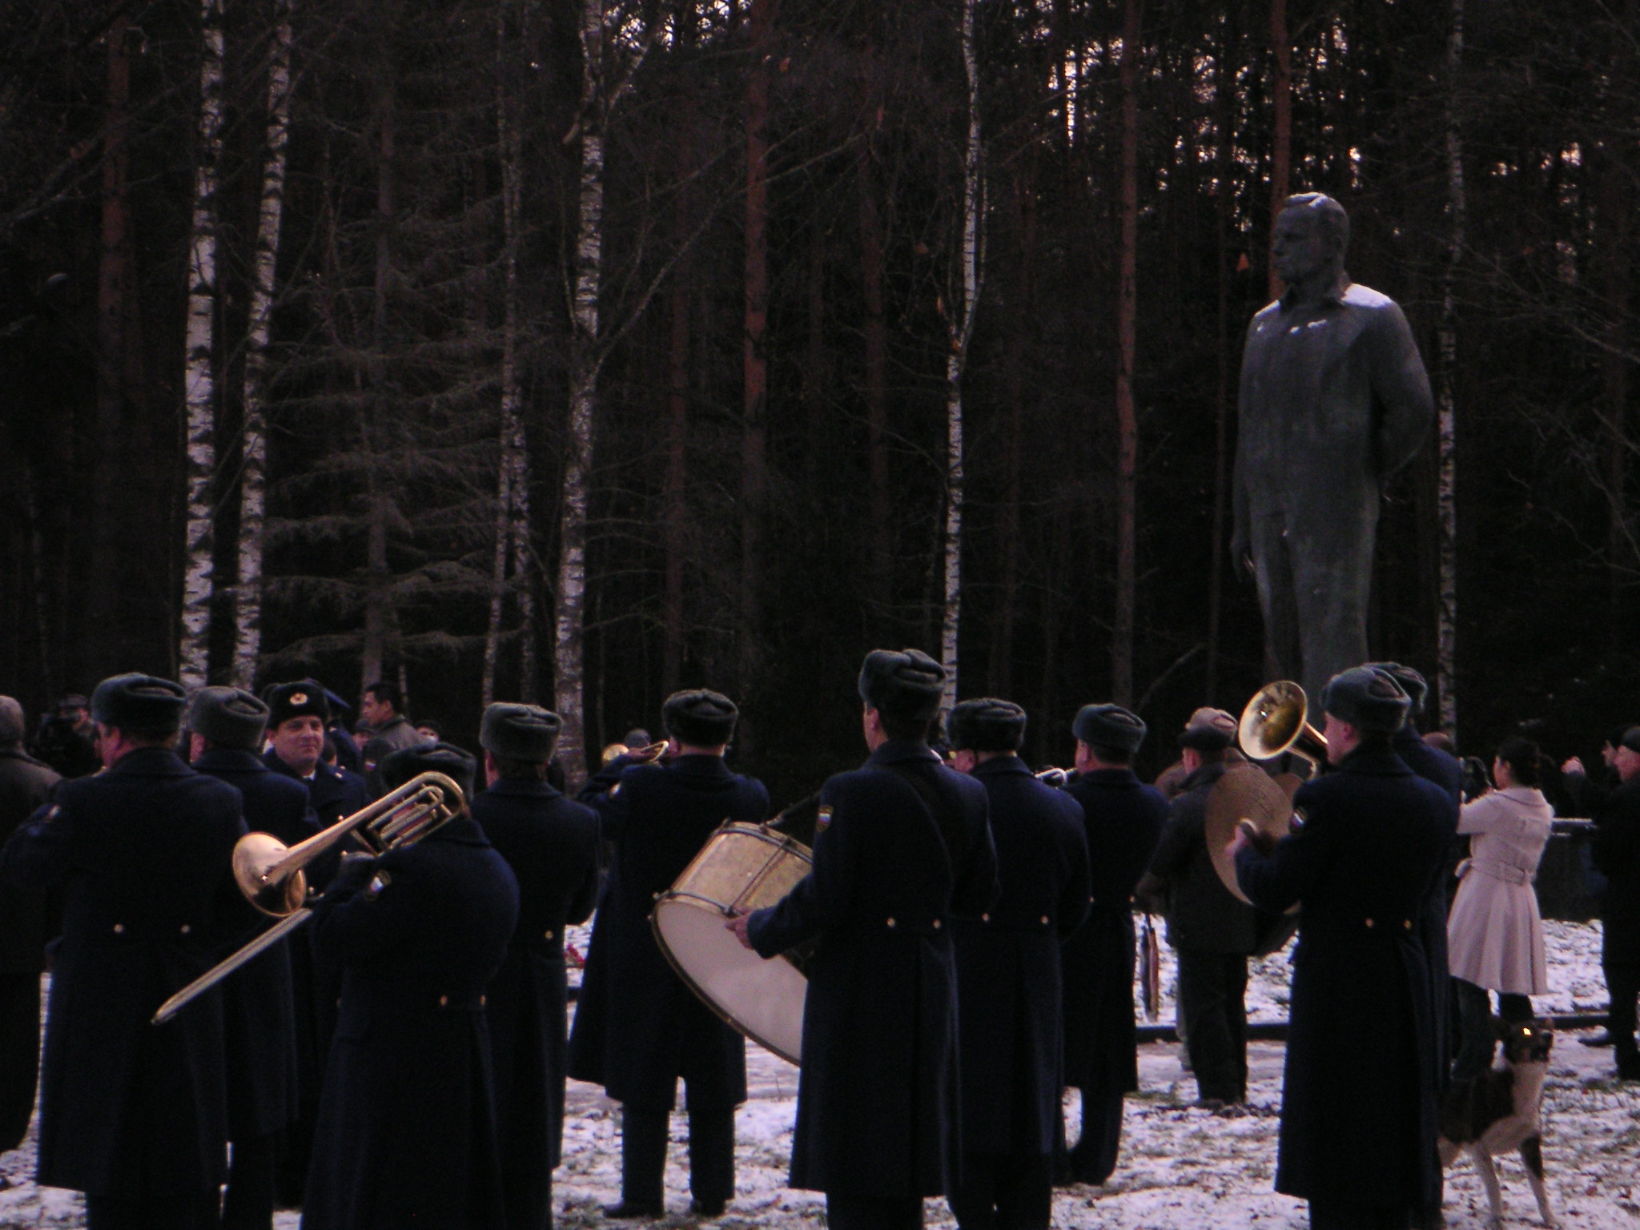

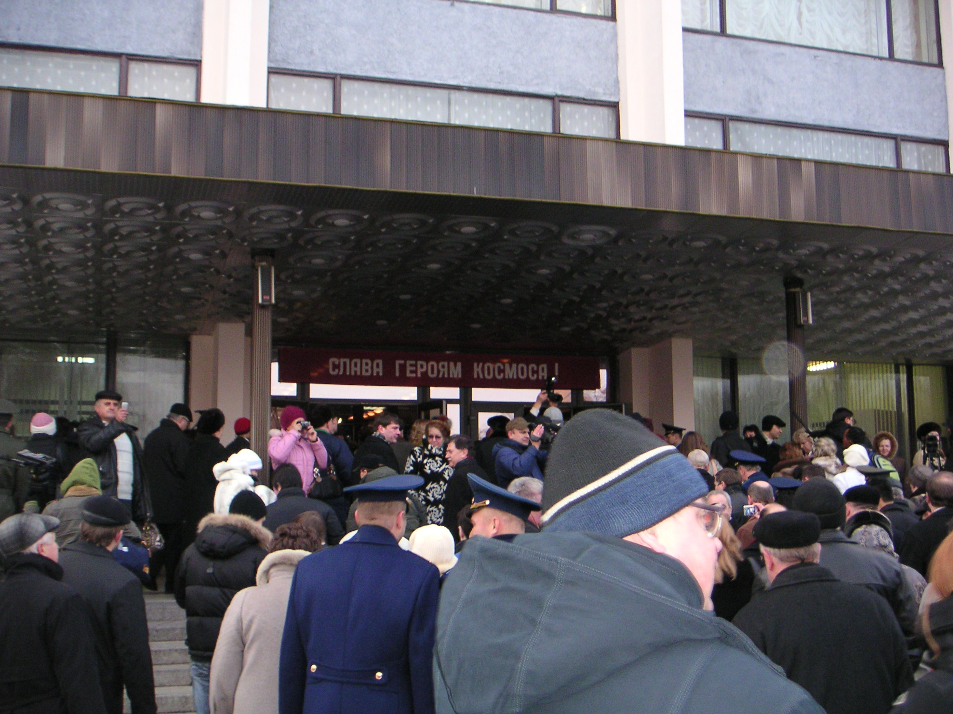

After the formal affair, we had a "shashlik" party for Suni. This is also a standard Russian thing - basically shashlik is a Russian shish-kebob, i.e., meat on a stick cooked outside over a fire. Quite yummy. I did not go to our party, but I did do a touch-n-go for some of the food. Though, at this point, doing more studying was probably not worth it.
Friday (drum roll, please) was my long awaited and long feared motion control test. From my point of view, it was very ugly. From theirs, well, I did great. How they figured that, I have no idea. Most of the questions seemed to be very weedy operational questions rather than the how-does-the-system-work type of questions. I knew how the system worked and I knew the first layer deep on how to operate with it. But, scheez, I had the hardest time figuring out what the heck they were after with the questions they were asking. Every once in awhile a light bulb would go off and I finally got to where they wanted me to be. But, for me, it was a painful process. It was probably painful for them as well. It was definitely a long hour and a half. But, somehow, they saw fit to give me top marks for both systems. Go figure.

After the test we had a little celebration. The Russian training integrators and other astronauts here clued me in that that was a tradition and that I needed to be prepared with a bottle of vodka or two and some snacks. So, I was. That part was good. Although, vodka at 10:30 in the morning is probably only a good idea if you do not have any other classes later on. Unfortunately, I did have to go to a couple more classes today.

All the instructors were very nice after the test - the old guard guys asked me if they had asked me too many questions. Of course, I am thinking to myself - this is your test, you get to ask me whatever you want. . . The main old guard Soyuz simulator instructor had asked a lot of questions on rendezvous operations that we had never covered in these motion control classes. He said that he only asked me all those questions to prepare me for my upcoming training in the simulator. My old guard analog loop instructor told me that I have all this info in my head and once I get into the simulator I will learn what I really need to know, but I will have my knowledge to call on when needed. And, finally, the old guard digital loop guy gave a toast to my digital loop instructor and said that he had done well with his first foreign student. So, I guess, all in all, old guard was pleased. And, that is all that counts.

Then, I had to sit through a two more radio location system classes. I do not know what it is about comm. systems, but, in my opinion, the instructors seem to be the most undynamic instructors of any systems. I do not know if such systems attract such people or if the system turns the people into such instructors, but in the Shuttle world and in the Soyuz world, it is the same. All very nice and very competent people, but rather pedantic. Because I was following the lectures well enough, we were ahead of schedule. So, instead of ending class early, the instructor took the path of since we have more time I will tell you more minutiae even though you do not need to know it. Oi!

Once my classes were finally done, I did nothing but relax. Well, I did spend some time in the gym, but I did not work out too hard. There are currently four astronauts here, including myself and Suni, and we got together for dinner and wine. It was nice. Though, we did stay up rather late yakking.

My weekend was fairly low key. Suni and I went into Moscow on Saturday and spent the day with the lady and family that we both had lived with for our Russian language immersion training. It was a lot of fun. We just sat around and ate and drank tea and talked. It was a very comfortable and relaxing day.

Sunday, I made a weak attempt at studying. I have one more test to go before I leave next Friday. But, admittedly, I could not whip up much enthusiasm for reading the training manuals. I found all kinds of ways to procrastinate. None of them, however, involved going outside. It did not get above freezing at all this week. I would not be surprised if it stayed below freezing until next March or April.

© Shannon Walker 2009

fun, I had another practical session on the laptops for the Russian segment. It was a nice mental break. My last activity for the week was my test on the launch escape and landing aids systems. It went just fine. Actually, it was not too bad, as tests go.
Whew! What a week. I took the evening off and hung out with the current folks in town.
My weekend was typical - grocery store on Saturday and study on Sunday. It snowed a bit this weekend as well. Not as much as it did before, but enough to cover the ground and make things slippery to walk on. I do not think this snow is going to melt any time soon. The forecast is not calling for us to get above freezing at all this week.
© Shannon Walker 2009

